Setting Up Crysis2 Dedicated Servers by rental customers, Version: 0.9

RCON connectivity
Crysis 3 supports the same HTTP/XML-RPC protocol from Crysis 2. Your server provider will inform you of the IP, port and password required.

Once started, you can use a third party HTTP/XML-RPC client (there is no internally developed HTTP/XML-RPC client available at this time).

Crysis 3 also supports the same rcon protocol from Crysis 2.Your server provider will inform you of the IP, port and password required.

Clients will be able to connect to the dedicated server by using the following command on their in-game console:

rcon_connect addr:%external IP of the dedicated server% port:%port as specified on the dedicated server% pass:%password as specified on the dedicated server%

Once connected, commands may be issued to the dedicated server by using the following command on their in-game console:rcon_command %command%
where %command% is the remote command that they wish to execute on the dedicated server, e.g. rcon_command sv_maxplayers 8

Clients may disconnect from the rcon server by using the following command on their in-game console:rcon_disconnect

Setting the RCON Password:
The rcon password can be set with rcon_password=password in your dedicated.cfg
If rcon_password is not set, rcon will try to use http_password.
If you're intending to use the same password for http and rcon, then you only need to start rcon with rcon_startserver port:xxxx

Level Rotation.xml
Custom level rotation files can be created easily with a LevelRotation.xml file, using either built-in or custom playlists and variants. Once the LevelRotation.xml file has been created (see examples below), place it in the root of the build (the same directory as dedicated.cfg).

Note: If you do not intend to change a setting, it doesn’t need to be in the LevelRotation.xml file.

Note: we have provided a number of example LevelRotation.xml files for you to play with

Firstly, using a standard playlist:
If the name of the LevelRotation is one of the existing playlists, i.e. "TDM","DM ", "CRASHSPEARS", "EXTCTF", "HUNTER", "ASSAULT", "MEDLEY", "CELLREBEL", "DESIGN", "TDMPRO", "DMPRO" then it will use one of these inbuilt playlists for the map/mode combinations. Any map/mode combo's specified in the LevelRotation.xml will be ignored. These playlists mirror the console playlists, as did Crysis 2. MEDLEY is all levels with all game modes whereas CRASHSPEARS contains a mixture of CRASHSITE and SPEARS game modes.

<levelRotation name="TDM" randomize = "0" includeNonPresentLevels = "1">
<ServerInfo>
<Details name="TDM All Level Rotation" />
<Variant name="Standard">
</Variant>
</ServerInfo>

</levelRotation>

Secondly, A Custom Level Rotation
This is LevelRotation1.xml supplied along with this document. If you specify "CUSTOM" as the name, then you can specify a list of map/mode combinations that the playlist will iterate through. If for example you wish to make a Crash Site only playlist, which is not provided as a standard playlist, just create a custom playlist like below but with gameRules="CrashSite" entries in the level nodes. CELLREBEL is the replacement for Vanilla sub-playlists (it was very rarely used in Crysis 2). However it should be able to be applied to any custom playlist by changing <Variant name="Standard"> to <Variant name="Vanilla"> in LevelRotation.xml

<levelRotation name="Custom" randomize = "0" includeNonPresentLevels = "1">
<ServerInfo>
<Details name="TDM All Level Rotation" />
<Variant name="Standard">
</Variant>
</ServerInfo>

<level name="Multiplayer/c3mp_museum" gameRules="TeamInstantAction" />
<level name="Multiplayer/c3mp_rooftop_gardens" gameRules="TeamInstantAction" />
<level name="Multiplayer/c3mp_con_ed" gameRules="TeamInstantAction" />
<level name="Multiplayer/c3mp_airport" gameRules="TeamInstantAction" />
<level name="Multiplayer/c3mp_bridge" gameRules="TeamInstantAction" />
<level name="Multiplayer/c3mp_canyon" gameRules="TeamInstantAction" />
<level name="Multiplayer/c3mp_dam" gameRules="TeamInstantAction" />
<level name="Multiplayer/c3mp_river" gameRules="TeamInstantAction" />
<level name="Multiplayer/c3mp_swamp_boat" gameRules="TeamInstantAction" />
<level name="Multiplayer/c3mp_tanker" gameRules="TeamInstantAction" />
<level name="Multiplayer/c3mp_cave" gameRules="TeamInstantAction" />
<level name="Multiplayer/c3mp_fields" gameRules="TeamInstantAction" />

</levelRotation>

Creating a matched pair playlist:
This is LevelRotation3.xml in the provided examples. You can setup your rotation with multiple modes for one level entry. If this is done the randomisation will be 'better' (for example a level won't be selected for a second time before every level has been selected for the first time). See levelrotation2.xml
You can set maintain pairs so each pair of entries in the level rotation will be kept together when randomised. Example usage of this would be so users always have to vote between different modes on one map. Or if you duplicate all your level entries with maintain pairs you can disable voting completely. See levelrotation3.xml (shown below):

<levelRotation name="Custom" randomize = "1" includeNonPresentLevels = "1" maintainPairs ="1">
<ServerInfo>
<Details name="Matched Pairs Server" />
<Variant name="Standard">
</Variant>
</ServerInfo>

<!--This section the player’s area always offered a choice of 2 modes on one map-->

<level name="Multiplayer/c3mp_con_ed" gameRules="CrashSite" />
<level name="Multiplayer/c3mp_con_ed" gameRules="TeamInstantAction" />

<level name="Multiplayer/c3mp_canyon" gameRules="Gladiator" />
<level name="Multiplayer/c3mp_canyon" gameRules="TeamInstantAction" />

<level name="Multiplayer/c3mp_dam" gameRules="CaptureTheRelay" />
<level name="Multiplayer/c3mp_dam" gameRules="TeamInstantAction" />

<!-- This section players are not offered a vote, game will be the duplicated map/mode combo -->

<level name="Multiplayer/c3mp_rooftop_gardens" gameRules="TeamInstantAction" />
<level name="Multiplayer/c3mp_rooftop_gardens" gameRules="TeamInstantAction" />

<level name="Multiplayer/c3mp_museum" gameRules="PowerStruggle" />
<level name="Multiplayer/c3mp_museum" gameRules="PowerStruggle" />

<level name="Multiplayer/c3mp_airport" gameRules="CrashSite" />
<level name="Multiplayer/c3mp_airport" gameRules="CrashSite" />

</levelRotation>

Finally, using a custom variant
<levelRotation name="TDM" randomize = "0" includeNonPresentLevels = "1">
<ServerInfo>
<Details name="Custom Variant Server" />
<Variant name="Custom">

<Option setting="g_maxHealthMultiplier 1.0" /> <!--Multiplyer (default=1.0) -->
<Option setting="g_mpRegenerationRate 1" /> <!-- 0=slow, 1=normal, 2=fast (default=1) -->

</Variant>
</ServerInfo>

</levelRotation>

Additional LevelRoation Notes:
'includenonpresentlevels' means add this level to the level rotation even if it doesn't exist in the levels folder (default behaviour is to skip any levels the game cannot find).
It is mainly for DLC support on console playlists, use on dedi server level rotations is optional. The main difference is if there is a typo in one of the level names would you rather the server presents a level which doesn't exist and will fail to load (with includenonpresentlevels = 1), or silently skip adding it to the level rotation and it would not show up (without includenonpresentlevels).

Weapon Indices for g_forceWeapon (-1 means players choose weapons as normal):

Index | Weapon | Index | Weapon
0 | SCARAB | 11 | Grendel
1 | Marshall | 12 | Gauss
2 | DSG1 | 13 | K-Volt
3 | Mk70 | 14 | SCAR
4 | Feline | 15 | Mike
5 | FY71 | 16 | LTag
6 | NanobowMP | 17 | Nova
7 | Mk60 | 18 | AY69
8 | Typhoon | 19 | Hammer
9 | Takedown | 20 | Revolver
10 | Jackal

Dedicated.cfg
It's possible for you to set up a custom level rotation file, or change CVARs directly. Changing any of the following will result in the match being UNRANKED. Users will be informed via in-game UI.

g_timelimit  g_scoreLimit  g_minplayerlimit  g_autoReviveTime  g_roundlimit  g_numLives  g_maxHealthMultiplier  g_mpRegenerationRate  g_friendlyfireratio  hud_radarTypeMP  g_mpHeadshotsOnly | g_allowCustomLoadouts  g_allowSuitPerks  g_allowTeamPerks  hud_dogtagsEnable  g_allowFatalityBonus  g_modevarivar_proHud  g_modevarivar_disableNanosuit  g_modevarivar_disableKillCam  g_modevarivar_disableSpectatorCam  g_allowExplosives  g_forceWeapon

The following CVARs can be safely changed without affecting whether the match is ranked or not:

g_autoAssignTeams  gl_time  g_gameRules_startTimerLength  g_pinglimit  g_pinglimittimer  g_punishfriendlydeaths | gl_initialTime  sv_maxPlayers  g_tk_punish  g_tk_punish_limit  g_idlekicktime

All these CVARs may be set in the dedicated.cfg file, or in the LevelRotation.xml file. If they're specified in multiple places, dedicated.cfgtakes priority, followed by LevelRotation.xml.

For example, if you have:
sv_maxPlayers=10 in dedicated.cfg, and
<Detailsname="Colin's Server"password="abc"motd="Welcome to the server"maxPlayers="8"/>in LevelRotation.xml
Since dedicated.cfgtakes priority, sv_maxPlayers would be 10. If it wasn't specified in dedicated.cfgthe LevelRotation.xml setting of 8 would be applied.

Note: The minimum number of players for a ranked match is 4.

additional commands for controlling a Dedicated Server
These can be typed in on in-game console:

sv_gamerules<mode> - allows you to run a specific game variation:

Full Name | Alias | Alternate Alias
Instant Action | IA | DM
Team Instant Action | TIA | TDM
Capture The Relay | CTR
Crash Site | CS
Assault | AS
Extraction | EXT
Hunter | HTR
Spears | SPR

INSTANT ACTION– Free-for-all deathmatch where everyone is an enemy. Whoever scores the most kills within the time limit, wins. You'll need to push the Nanosuit to its limit swapping between armor mode and stealth as the action comes fast and heavy.

TEAM INSTANT ACTION – Two teams go head to head in this deathmatch mode. Your objective is to score more points than the opposing team within the time limit by eliminating as many opponents as you can. Utilize the power of the Nanosuit, and good teamwork, to win!

CAPTURE THE RELAY – Two teams face off and try to capture one another's relays. Each team possesses a relay at their base which must be defended. To score you must capture your enemies relay and deliver it to your base. Use the Nanosuit tactically to armor up and defend your base, or take the stealth approach and sneak in to grab the enemy relay.

CRASH SITE– This team-based mode sees two teams fight for control of alien pods. Alien ships will launch pods at various locations. Secure and hold the alien pod sites to score points. Pods will expire over time so watch the skies and be ready to move on the next location!

EXTRACTION– In this round-based mode one team must locate alien creatures called Ticks which are being guarded by the defending team, and bring them back to the extraction point where an escape helicopter awaits. Extracting a tick gives the team an energy upgrade to the Nanosuit which can be used tactically to capture the remaining ticks. There are two Ticks: an armor Tick and a stealth Tick

ASSAULT – An asymmetrical game mode where one team play equipped with Nanosuits, attempting to infiltrate the enemy stronghold and download the vital blueprints from terminals. The other team play as special force soldiers with brutal weaponry but without the dynamic abilities of the Nanosuit. Four rounds and only one life per-player per-round. The team that manages to download the most data across the rounds wins

HUNTER – Play as the hunter or the prey across five rounds in this mode. Hunters are Nanosuited-marines with unlimited stealth, armed only with the Nanobow. CELL operatives have superior numbers and firepower, but respawn as Hunters when killed. As a Hunter kill all the CELL to end the round, as a CELL operative just stay alive until the timer runs out to win.

SPEARS – Fight for control over three Alien Spears in this team based mode. Stand in the Spear's capture radius to claim it. Holding Spears earns objective points for your team, the more Spears you hold the faster you earn. Each Spear houses 2 panels that can be ripped off and used as shields for defense. The first team to earn 100 points wins.

Note:If you're starting the server using the startplaylist command (below), there is no need to set the game rules as the server will use whatever is specified in the playlist
Note: sv_gamerules accepts the full name, alias or alternate alias as a parameter

Note: startplaylist<mode>__<modifier> - runs through all the maps of a particular mode and modifier

Mode | Standard | Pro | BeginnersPlayground
Assault | X
Crash | X
CTF | X
Extraction | X
DM | X | X | X
TDM | X | X | X
Hunter | X
Spears | X
e.g. startplaylist IA__BeginnersPlayground
Note: you can also tab complete the game modes.
STANDARD – Regular version of the game mode for players of any rank. Supported on all game modes

BEGINNER'S PLAYGROUND – This mode is tailored for newcomers to the game, with participants limited to those of rank 10 and under. Supported on Death Match and Team Death Match only

PRO – Pro mode allows hardened veterans to battle with reduced health, limited HUD and without support bonuses. Supported on Death Match and Team Death Match only

map <map> - start a map that you specify. Map names can be found in <build folder>\GameCrysis3\levels\wars\...
gl_time<number> - sets the time between rounds (in seconds)
gl_initialtime<number> - sets the time until a round starts when the minimum number of players join
g_minplayerlimit<number> - sets the minimum number of players required to start the match
g_timelimit<number> - sets the time limit for each round (in minutes, 0 = infinite time)
g_scorelimit<number> - sets the score need to finish the round (0 = infinite score)
gl_startgame - starts the server, ignoring the minimum number of players and initial time.
g_messageoftheday<message of the day> - used to display a message on the loading screen (maximum of 165 characters). See example screenshots at the end of the document.
g_serverimageurl<URL to the server image>, which should be 128x64, and either jpg or png (png is preferred due to it supporting transparency). See example screenshots at the end of the document.
status - shows the status of the running server (see FAQ at the end of this document for details)
g_pinglimit – Max ping a player can have before being kicked (0 = disabled) / Default: 0
g_pinglimittimer – Time after which a player will be kicked if they are over the specified ping limit / Default: 15
g_tk_punish – Turns on punishment for team kills / Default: 1
g_tk_punish_limit – Number of team kills user will be banned for / Default: 5
g_idlekicktime – Time to wait before kicking a player for being idle for too long (in seconds) / Default: 120
g_punishfriendlydeaths – The player gets punished by death when killing a friendly unit / Default: 1

Nickname | Level Name | Nickname | Level Name
Airport | c3mp_airport | Penn Depot | c3mp_fields
Brooklyn Bridge | c3mp_bridge | Museum | c3mp_museum
Financial District | c3mp_canyon | Hells Kitchen | c3mp_river
Central Cavern | c3mp_cave | Skyline | c3mp_rooftop_gardens
East River | c3mp_con_ed | Chinatown | c3mp_swamp_boat
Hydro Dam | c3mp_dam | Williamsburg | c3mp_tanker
Note: all maps support all modes!

Server Kick Vote System
The old console vote kick system still exists in Crysis 3 – its use is detailed below. In addition, Crysis 3 supports additional in-game UI for initiating a vote kick (select from context menu on selecting a player on the scoreboard).

Usage (Client):

Initiating a vote
Bring down the console and type 'votekick <playername>', and hit enter. The server will then respond with a string over text chat "Vote to kick <playername> initiated"

Casting a 'yes' vote
Bring down the console, type 'vote', and hit enter

Casting a 'no' vote
Do nothing; anyone failing to vote will have counted as a 'no'

Usage (Server):
CVar Name | Value Type | Valid Values | Default Value | Comments
sv_votingCooldown | Time in seconds | 1 - 9999999 | 180 | Controls how soon the same player can initiate another vote
sv_votingRatio | Fraction | 0.0 - 1.0 | 0.51 | The fraction of players that have to vote 'yes' in order for someone to be kicked
sv_votingTimeout | Time in seconds | 1 - 9999999  1 - 9999999  1 - 9999999 | 60 | Controls how long until the vote ends and the results acted upon
sv_votingEnable | Integer | 0 / 1  0 / 1 | 1 | Control whether kick voting is enabled on this server
sv_votingBanTime | Float | 0.1 - 999999 | 10 | Time in minutes for which the user is kickbanned when kicked of the server by a vote

Server Ban System

Overview
Dedicated server host can now choose to ban people permanently or for specific periods of time. This ban will persist over server restarts.

Usage
There are four main commands to administer player bans
- ban <playername> - bans player for whatever the timeout is currently
- ban_timeout <minutes> - Sets the ban time. A time of 0 is permanent
- ban_remove <playername> - Removes the ban
- ban_status - Lists the currently banned players and times

Server Reserved Slots System

Overview
The system is designed to allow server administrators to create and maintain a list of reserved users that have priority over non-reserved users. For example, clan members may wish to allow their rented server to be used by the public, but also that they can play on it whenever they wish.

Usage
There are four commands used to administer the reserved slots system:
- net_reserved_slot_system<1 | 0> - turns the reserved slot system on/off
- net_add_reserved_slot<name> - adds the named player to the reserved slots system
- net_remove reserved_slot<name> - removes the named player from the reserved slots system
- net_list_reserved_slot - lists all players in the reserved slots system
All these commands must be entered on the server either directly, or via RCON or HTTP XML-RPC.

Additional Information
The system persists the reserved slots list to the file reservedslots.cfg in the root of the dedicated server instance (the location specified by -root on the command line). It is loaded and parsed regardless of whether the system is turned on or off, but is only acted upon when the system is on.
If a lobby or game is full, and a reserved user tries to join, a non-reserved user will be kicked with the message "Kicked in favour of a priority user", and the reserved user will take their place.
The reserved slots system works strictly with the players named in the list. If a reserved user creates a squad that includes non-reserved users, and there is insufficient space on the server for the entire squad, then the join will fail even for the reserved user as preserving the squad integrity is deemed more important. It is up to the server administrator to add squad members to the reserved slots list in order to allow them to join a full server, if desired.
The reserved slots list is dynamic and can be changed at any point, even mid-game.

MEssage of The DAY & Server IMAGE (YES THESE IMAGES ARE FROM Crysis 2)
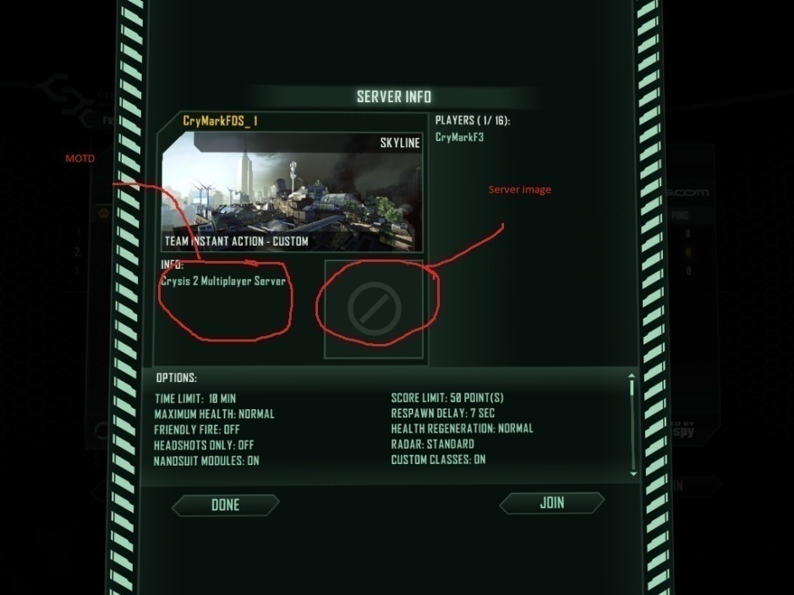 | 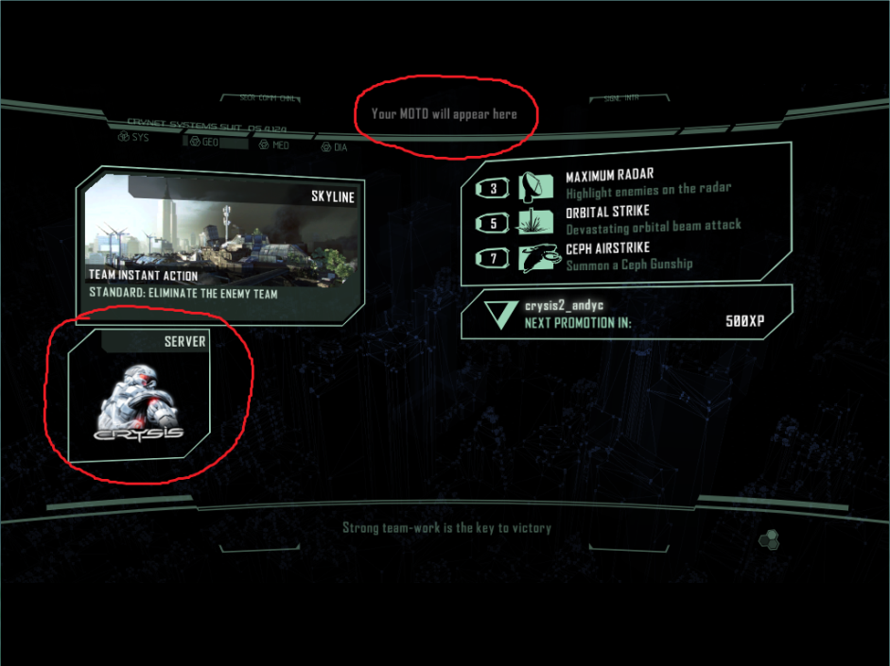
Server Info Screen showing MOTD and Server Image | Loading Screen showing MOTD and Server Image

Frequently asked questions
Q: Is there a way for me to check if a server is up or not?
A: Yes, use the 'status' command
When in the lobby you'll see something like this:
----------------------------------------
Server Status:
name: <nickname of the account used to start the dedi>
ip: <host name>
version: x.x.x.x
level: lobby
gamerules: unknown
players: 0/16
time remaining 0:00
----------------------------------------
Connection Status:
<any players get listed here>
N.B. you'll always see gamerules: unknown, max players as 16 and 0:00 time when in the lobby. When in the game you'll see something like this:
----------------------------------------
Server Status:
name: <nickname of the account used to start the dedi>
ip: <host name>
version: x.x.x.x
level: Wars/cw2_rooftop_gardens
gamerules: InstantAction
players: 1/16
time remaining 9:57
----------------------------------------
Connection Status:
<any players get listed here>

Q: I can't see my server in the client's game browser. I'm using the supplied LevelRotation.xml file...what's wrong?
A: The LevelRotation.xml file supplied should work 'out of the box', but if you've edited it, please check that you've not inadvertently broken the XML formatting. The easiest way to check if the file is still valid is to open it in Internet Explorer - if it's a valid XML file, it'll be displayed. If you get errors about invalid characters, it's probably a white space issue (it's better to use spaces rather than tabs to indent the various sections). If the XML looks correct, please check that you've specified a valid map/mode/variant according to the tables in this document.

